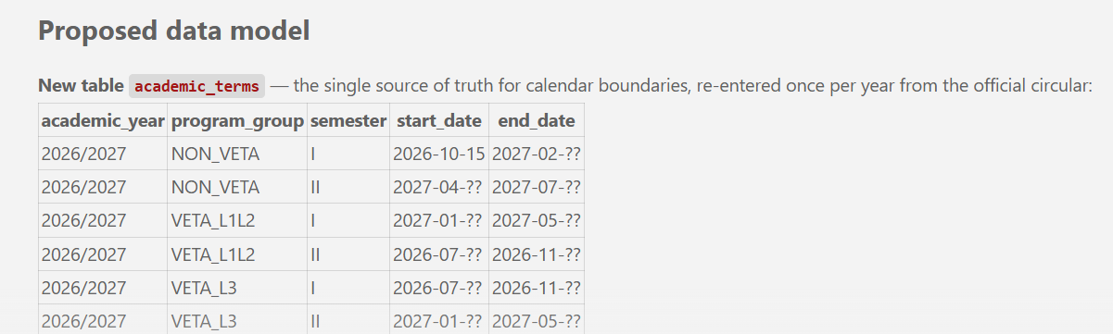

Final confirmed calendar:
Program group | Semester I | Semester II
NON-VETA | Oct, Nov, Dec, Jan, Feb | Mar, Apr, May, Jun, Jul
VETA L1/L2 | Jan, Feb, Mar, Apr, May | Jul, Aug, Sep, Oct, Nov
VETA L3 | Aug, Sep, Oct, Nov | Jan, Feb, Mar, Apr, May
That's everything needed to implement this. Given the file you selected earlier (models/manualTimetableModel.js, the collision-check block in addtimetable), here's what I'd do as the first, pilot implementation:
- Add the SEMESTER_CALENDAR constant and a getProgramGroup(program_type, program_level) helper near the existing SLOT_RANGES/programSlotMatch (same file, same pattern).
- Add a semestersOverlap(entryA, entryB) helper.
- In the collision-check block you selected: drop AND semester = ? from the SQL so it fetches all existing entries for that day+slot, then filter with semestersOverlap(...) before the tutor/venue/program checks run (which stay untouched).
- Verify live: create a real test scenario where a VETA and a non-VETA booking share a day/slot/venue during one of the confirmed overlap windows (e.g. October, where NON-VETA Sem I and VETA L1/L2 Sem II both run) — confirm the old code would have missed it, and the new code catches it. Then revert the test data, same discipline as every other change this engagement.
Want me to go ahead and implement this in manualTimetableModel.js now? (Once it's verified there, we can decide together whether to roll the same helpers out to the other collision-check sites — timetablesLogic.js, routes/timetables.js, tmasterModel.js — as separate steps.)

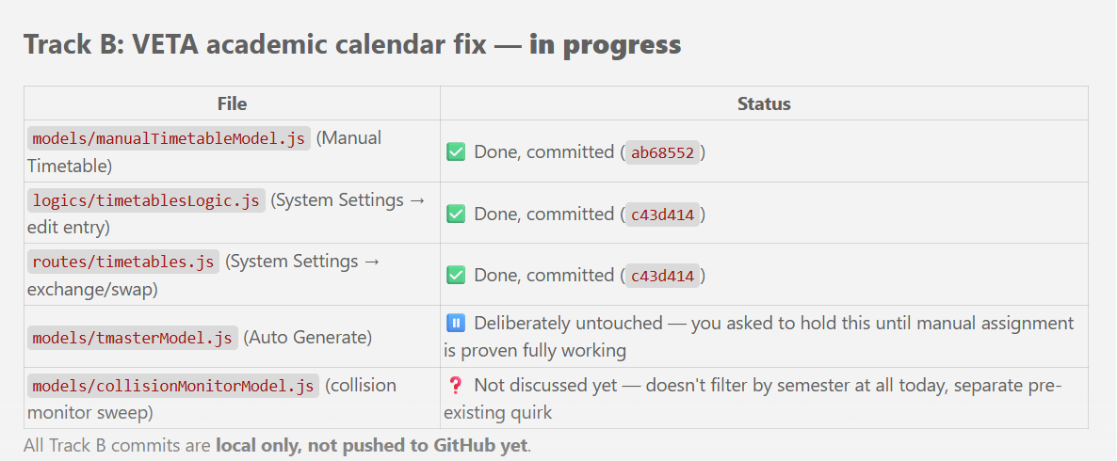

##########################################################################

program_group is derived automatically, not stored redundantly: program_type='VETA' AND program_level IN ('1','2') → VETA_L1L2; program_type='VETA' AND program_level='3' → VETA_L3; everything else → NON_VETA.
extracted_timetables (and subjects) gets a new term_id (FK into academic_terms), resolved once at creation time — not derived later from created_at, since that would be fragile. This is what lets a booking permanently "remember" which real dated term it belongs to, even years later when old rows are still sitting in the table.

Proposed collision logic
Replace the ~5 duplicated semester = ? filters with one shared function — something like termsOverlap(termIdA, termIdB) — that looks up both terms' [start_date, end_date] and tests real interval overlap (start1 < end2 && start2 < end1), reusing the exact overlap-math pattern already in collisionMonitorLogic.js for time-of-day breaks. Two bookings only get checked against each other if their terms genuinely overlap in real time — this correctly handles the triple-overlap months without any special-casing.

Suggested rollout order
This is a big change (new table, new FK column, rewriting 5 call sites, plus a yearly maintenance step for whoever manages the calendar). I'd suggest staging it the same way we've done everything else — one piece at a time, verified against live data before moving on:
- Create + seed academic_terms with this year's real dates (I only have exact days for NON-VETA Sem1 start — Oct 15 — the other five ranges still need exact days, not just months, now that we know they matter).
- Add term_id resolution to one creation path first — manual timetable assignment, since we already understand that file in depth — as a pilot.
- Wire the shared termsOverlap() check into that same path's collision logic, verify against real conflicting VETA/non-VETA bookings.
- Roll the same pattern out to the other 3-4 collision-check sites.
- Figure out the yearly maintenance step (a small admin form, or just direct entry — your call).
Does this direction look right, and can you get me the exact end/start days for the other five ranges when you're back with them?

I don't want the type of situation where a collision will occur, apart from the collisions that were already controlled in the timetable function's code. The system should prevent timetable clashes involving tutors, programs, or venues assigned to different semesters.

You've got it exactly right, and I think my last message buried the actual point under too much database terminology. Let me re-explain it anchored directly to the code you selected.
Look at just this one line — it's the entire problem:
WHERE day = ? AND slot = ? AND semester = ?
This line decides which existing bookings even get compared against the new one. Everything below it — the tutor check, the venue check, the program check — only ever looks at whatever this query hands it. Those three checks are all correct and don't need to change.
The bug: semester = ? only pulls rows with the exact same label. So if you're assigning a VETA Level 1 class (semester label "I") into a venue on Monday 09:05–09:50, and a non-VETA class is already booked in that same venue at that same day/time with semester label "II" — this query returns nothing for it. The venue-conflict check never even sees that row, so the system says "no conflict" and lets you double-book the room, even though (per the dates you gave me) VETA Sem I and non-VETA Sem II can genuinely run during the exact same weeks.
So: nothing about how collisions are detected needs to change. The only thing that needs to change is which existing rows are even considered — right now that's "same semester label," and it needs to become "same real time period," because those two stopped being the same thing for VETA.
That's the whole idea behind the academic_terms table, said plainly: it's a small lookup — "this program group's Semester I this year runs from this date to that date" — so that line can ask "do these two entries' semesters actually overlap in real time?" instead of "do these two entries have the identical label?" Nothing else in this function changes.
Does that match what you meant? And — this is the one thing still blocking me from designing it precisely — I still need the exact start/end days (not just months) for the other five ranges, since we confirmed the dates shift year to year:
- NON-VETA Sem 1 end (Feb ?)
- NON-VETA Sem 2 (Apr ? – Jul ?)
- VETA L1/L2 Sem 1 (Jan ? – May ?)
- VETA L1/L2 Sem 2 (Jul ? – Nov ?)
- VETA L3 Sem 1 (Jul ? – Nov ?)
- VETA L3 Sem 2 (Jan ? – May ?)

